**Lab 6**

Jiho Kim, Garth Slaney

ENSF 480 | Principles of Software Design

Submission Date: October 29, 2020

University of Calgary

**ExA**

import java.util.ArrayList;

/**

* A subject with a array list of doubles

* @author Garth-Work

*

*/

public class DoubleArrayListSubject implements Subject {

/**

* The data to be stored

*/

private ArrayList<Double> data;

/**

* All observers tracking this data

*/

private ArrayList<Observer> observers;

public DoubleArrayListSubject() {

data = new ArrayList<Double>();

observers = new ArrayList<Observer>();

}

/**

* Add an entry to the list and notify all obervers

* @param d Double to be added

*/

public void addData(double d) {

data.add(d);

notifyAllObervers();

}

/**

* Change a list entry and notify all observers

* @param d Double to be added

* @param postion Postion to change

*/

public void setData(double d, int postion) {

data.set(postion, d);

notifyAllObervers();

}

/**

* Copy double array to array list

* @param arr Array to be populated to array

*/

public void populate(double[] arr){

for(double d : arr) {

data.add(d);

}

notifyAllObervers();

}

@Override

public void registerObserver(Observer o) {

observers.add(o);

o.update(data);

}

@Override

public void remove(Observer o) {

observers.remove(o);

}

@Override

public void notifyAllObervers() {

for(Observer o: observers)

o.update(data);

}

/**

* Display the list through all observers

*/

public void display() {

if(data.size() == 0)

{

System.out.println("Empty List ..");

}

else {

notifyAllObervers();

}

}

}

import java.util.ArrayList;

/**

* Display data in five rows

* @author Garth-Work

*

*/

public class FiveRowsTable_Observer implements Observer{

/**

* Subject that is tracked

*/

private Subject sub;

/**

* The array of data

*/

private ArrayList<Double> arr;

public FiveRowsTable_Observer(Subject mydata) {

sub = mydata;

sub.registerObserver(this);

}

@Override

public void update(ArrayList<Double> arr) {

this.arr = arr;

display();

}

/**

* Display the data in five rows

*/

private void display() {

System.out.println("\nNotification to FiveRowsTable Observer: Data Changed:");

ArrayList<ArrayList<Double>> temp = new ArrayList<ArrayList<Double>>();

for(int i = 0; i<5; i++) {

temp.add(new ArrayList<Double>());

}

for(int i = 0; i < arr.size(); i++) {

temp.get(i%5).add(arr.get(i));

}

for(int i = 0; i<5; i++) {

for( double d : temp.get(i)) {

System.out.print(d + " ");

}

System.out.println();

}

System.out.println();

}

}

import java.util.ArrayList;

/**

* The interface for an observer

* @author Garth-Work

*

*/

public interface Observer {

/**

* Change the data stored

* @param arr Data to be changed to

*/

void update(ArrayList<Double> arr);

}

/* ENSF 480 - Lab 2

* M. Moussavi

*/

public class ObserverPatternController {

public static void main(String []s) {

double [] arr = {10, 20, 33, 44, 50, 30, 60, 70, 80, 10, 11, 23, 34, 55};

System.out.println("Creating object mydata with an empty list -- no data:");

DoubleArrayListSubject mydata = new DoubleArrayListSubject();

System.out.println("Expected to print: Empty List ...");

mydata.display();

mydata.populate(arr);

System.out.println("mydata object is populated with: 10, 20, 33, 44, 50, 30, 60, 70, 80, 10, 11, 23, 34, 55 ");

System.out.print("Now, creating three observer objects: ht, vt, and hl ");

System.out.println("\nwhich are immediately notified of existing data with different views.");

ThreeColumnTable_Observer ht = new ThreeColumnTable_Observer(mydata);

FiveRowsTable_Observer vt = new FiveRowsTable_Observer(mydata);

OneRow_Observer hl = new OneRow_Observer(mydata);

System.out.println("\n\nChanging the third value from 33, to 66 -- (All views must show this change):");

mydata.setData(66.0, 2);

System.out.println("\n\nAdding a new value to the end of the list -- (All views must show this change)");

mydata.addData(1000.0);

System.out.println("\n\nNow removing two observers from the list:");

mydata.remove(ht);

mydata.remove(vt);

System.out.println("Only the remained observer (One Row ), is notified.");

mydata.addData(2000.0);

System.out.println("\n\nNow removing the last observer from the list:");

mydata.remove(hl);

System.out.println("\nAdding a new value the end of the list:");

mydata.addData(3000.0);

System.out.println("Since there is no observer -- nothing is displayed ...");

System.out.println("\nNow, creating a new Three-Column observer that will be notified of existing data:");

ht = new ThreeColumnTable_Observer(mydata);

}

}

import java.util.ArrayList;

/**

* Display the data in one row

* @author Garth-Work

*

*/

public class OneRow_Observer implements Observer{

/**

* Subject that is tracked

*/

private Subject sub;

/**

* The array of data

*/

private ArrayList<Double> arr;

public OneRow_Observer(Subject mydata) {

sub = mydata;

sub.registerObserver(this);

}

@Override

public void update(ArrayList<Double> arr) {

this.arr = arr;

display();

}

/**

* Display the data in one row

*/

private void display() {

System.out.println("\nNotification to OneRow_Table Observer: Data Changed:");

for(double d : arr)

System.out.print(d + " ");

System.out.println();

}

}

/**

* An interface for subject

* @author Garth-Work

*

*/

public interface Subject {

/**

* Add an observer

* @param o Observer to be addded

*/

void registerObserver(Observer o);

/**

* Remove an observer

* @param o Observer to be removed

*/

void remove(Observer o);

/**

* Notify all obervers

*/

void notifyAllObervers();

}

import java.util.ArrayList;

/**

* Display the data in three columns

* @author Garth-Work

*

*/

public class ThreeColumnTable_Observer implements Observer {

/**

* Subject that is tracked

*/

private Subject sub;

/**

* The array of data

*/

private ArrayList<Double> arr;

public ThreeColumnTable_Observer(Subject mydata) {

sub = mydata;

sub.registerObserver(this);

}

@Override

public void update(ArrayList<Double> arr) {

this.arr = arr;

display();

}

/**

* Display data in three columns

*/

private void display() {

System.out.println("\nNotification to Three-Column Table Observer: Data Changed:");

int i;

for(i = 0; i < arr.size()-2; i+=3) {

System.out.println(arr.get(i) + " " + arr.get(i +1) + " " + arr.get(i+2));

}

while(i < arr.size()) {

System.out.print(arr.get(i++) + " " );

}

System.out.println();

}

}

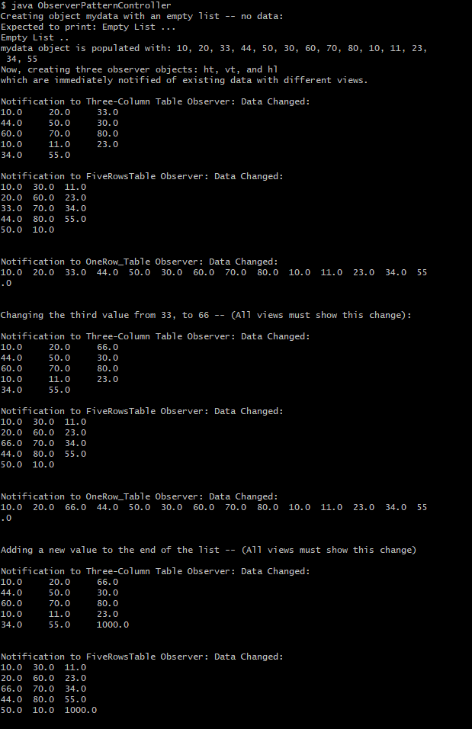

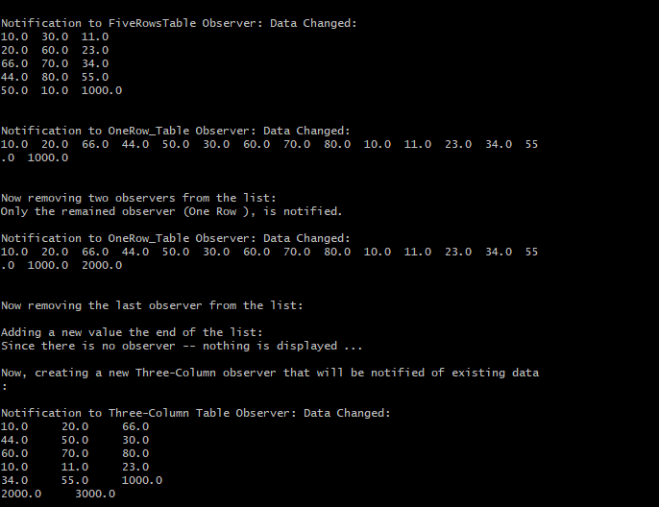

**ExB**

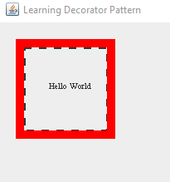

**ExC**

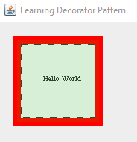

**Code for B&C**

import java.awt.Graphics;

// class used to show text.

public class Text implements Component {

protected int x;

protected int y;

protected String text;

Text(String message, int a, int b) {

text = message;

x = a;

y = b;

}

public void draw(Graphics g) {

g.drawString(text, x, y);

}

}

import java.awt.Graphics;

import java.awt.Graphics2D;

import java.awt.Stroke;

import java.awt.BasicStroke;

// this class is used to display the dashed border

public class BorderDecorator extends Decorator{

// normal constructor

BorderDecorator(Component com, int a, int b, int c, int d) {

super(com, a, b, c, d);

}

// this constructor is used when another Decorator is used as a parameter. Displays the Decorator by setting dec.

BorderDecorator(Decorator temp, int a, int b, int c, int d) {

super(temp.cmp, a, b, c, d);

dec = temp;

}

public void draw(Graphics g) {

if(dec != null) {

dec.draw(g);

}

Stroke dashed = new BasicStroke(3, BasicStroke.CAP_BUTT, BasicStroke.JOIN_BEVEL, 0, new float[]{9}, 0);

Graphics2D g2d = (Graphics2D) g;

g2d.setStroke(dashed);

g.drawRect(x,y,width,height);

}

}

import java.awt.Graphics;

import java.awt.Graphics2D;

import java.awt.Stroke;

import java.awt.BasicStroke;

import java.awt.Color;

// used to display thick border that's red.

public class ColouredFrameDecorator extends Decorator{

private int thickness;

// normal constructor

ColouredFrameDecorator(Component com, int a, int b, int c, int d, int e) {

super(com, a, b, c, d);

thickness = e;

}

// constructor for when another Decorator has to be shown.

ColouredFrameDecorator(Decorator temp, int a, int b, int c, int d, int e) {

super(temp.cmp, a, b, c, d);

thickness = e;

dec = temp;

}

public void draw(Graphics g) {

if(dec != null) {

dec.draw(g);

}

Graphics2D g2d = (Graphics2D) g;

// save previous stroke style

Stroke oldStroke = g2d.getStroke();

Color oldColor = g2d.getColor();

// set new stroke and draw rectangle

g2d.setStroke(new BasicStroke(thickness));

g2d.setColor(Color.red);

g2d.drawRect(x, y, width, height);

// set stroke back to what it was previously

g2d.setStroke(oldStroke);

g2d.setColor(oldColor);

}

}

import java.awt.Graphics;

import java.awt.Graphics2D;

import java.awt.Color;

import java.awt.AlphaComposite;

// class used to fill rectangle with a transparent background.

public class ColouredGlassDecorator implements Component{

protected ColouredFrameDecorator cfd;

protected int x;

protected int y;

protected int width;

protected int height;

ColouredGlassDecorator(ColouredFrameDecorator a, int b, int c, int d, int e) {

cfd = a;

x = b;

y = c;

width = d;

height = e;

}

public void draw(Graphics g) {

cfd.draw(g);

Graphics2D g2d = (Graphics2D) g;

g2d.setColor(Color.green);

g2d.setComposite(AlphaComposite.getInstance(AlphaComposite.SRC_OVER, 1*0.1f));

g2d.fillRect(x, y, width, height);

}

}

import java.awt.Graphics;

public interface Component {

public void draw(Graphics g);

}

// abstract class used to implement component. This will be used as the parent class to many different classes.

public abstract class Decorator implements Component {

protected Decorator dec = null;

protected Component cmp;

protected int x;

protected int y;

protected int width;

public int height;

// constructor

Decorator(Component com, int a, int b, int c, int d) {

cmp = com;

x = a;

y = b;

width = c;

height = d;

}

}

import java.awt.Font;

import java.awt.Graphics;

import javax.swing.JFrame;

import javax.swing.JPanel;

public class DemoDecoratorPattern extends JPanel {

Component t;

public DemoDecoratorPattern(){

t = new Text ("Hello World", 60, 80);

}

public void paintComponent(Graphics g){

// set font and show text on jpanel

int fontSize = 10;

g.setFont(new Font("Times New Roman", Font.PLAIN, fontSize));

t = new Text ("Hello World", 60, 80);

t.draw(g);

/*

// Now lets decorate t with BorderDecorator: x = 30, y = 30, width = 100, and height 100

t = new BorderDecorator(t, 30, 30, 100, 100);

t.draw(g);

// Now lets add a ColouredFrameDecorator with x = 25, y = 25, width = 110, height = 110,

// and thickness = 10.

t = new ColouredFrameDecorator(t, 25, 25, 110, 110, 10);

*/

// used to draw the border and fill the rectangle with green colour

t = new ColouredGlassDecorator(new ColouredFrameDecorator(

new BorderDecorator(t, 30, 30, 100, 100), 25, 25, 110, 110, 10), 25, 25, 110, 110

);

// Now lets draw the product on the screen

t.draw(g);

}

public static void main(String[] args) {

DemoDecoratorPattern panel = new DemoDecoratorPattern();

JFrame frame = new JFrame("Learning Decorator Pattern");

frame.getContentPane().add(panel);

frame.setSize(400,400);

frame.setDefaultCloseOperation(JFrame.EXIT_ON_CLOSE);

frame.setLocationRelativeTo(null);

frame.setVisible(true);

}

}

**ExD**

This program does not allow creating objects of LoginServer as the login server constructor is private.

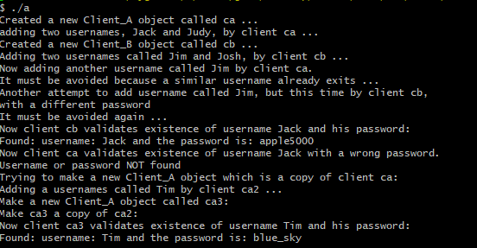

**Code**

#include <string>

#include <iostream>

#include <vector>

#include "LoginServer.hpp"

LoginServer* LoginServer::instance= nullptr;;

LoginServer* LoginServer::getInstance(){

if(instance == nullptr){

instance = new LoginServer();

}

return instance;

}

User* LoginServer::validate(string username, string password){

//Iterate over all users in vector

for(vector<User>::iterator u = users.begin(); u != users.end(); u++){

if(u -> username == username && u ->password == password){

return &(*u); //defrence then get the adress to return only a pointer to a user

}

}

return nullptr;

}

//Client_B.hpp

#ifndef Client_B_H // include guard

#define Client_B_H

#include <iostream>

#include <string>

#include "LoginServer.hpp"

class Client_B{

private:

LoginServer* instance;

public:

Client_B() {

instance = LoginServer::getInstance();

}

void add(string username, string password){

instance -> add(username, password);

}

User* validate(string username, string password){

return instance -> validate(username, password);

}

};

#endif

//Client_A.hpp

#ifndef Client_A_H // include guard

#define Client_A_H

#include <iostream>

#include <string>

#include "LoginServer.hpp"

class Client_A{

private:

LoginServer* instance;

public:

Client_A() {

instance = LoginServer::getInstance();

}

void add(string username, string password){

instance -> add(username, password);

}

User* validate(string username, string password){

return instance -> validate(username, password);

}

};

#endif

//

// main.cpp

// SigletonPattern

//

#include "Client_A.hpp"

#include "Client_B.hpp"

#include "LoginServer.hpp"

#include <iostream>

using namespace std;

int main() {

Client_A ca;

cout << "Created a new Client_A object called ca ..." << endl;

cout << "adding two usernames, Jack and Judy, by client ca ..." << endl;

ca.add("Jack", "apple5000");

ca.add("Judy", "orange$1234");

Client_B cb;

cout << "Created a new Client_B object called cb ... " << endl;

cout << "Adding two usernames called Jim and Josh, by client cb ..." << endl;

cb.add("Jim", "brooks$2017");

cb.add("Josh", "mypass2000");

cout << "Now adding another username called Jim by client ca.\n";

cout << "It must be avoided because a similar username already exits ..." << endl;

ca.add("Jim", "brooks$2017");

cout << "Another attempt to add username called Jim, but this time by client cb,\n";

cout << "with a different password\n";

cout << "It must be avoided again ..." << endl;

cb.add("Jim", "br$2017");

cout << "Now client cb validates existence of username Jack and his password: " << endl;

if( User *u = cb.validate("Jack", "apple5000"))

cout << "Found: username: " << u->username << " and the password is: " << u->password << endl;

else

cout << "Username or password NOT found" << endl;

cout << "Now client ca validates existence of username Jack with a wrong password. " << endl;

if( User *u = ca.validate("Jack", "apple4000"))

cout << "Found: username is: " << u->username << " and password is: " << u->password << endl;

else

cout << "Username or password NOT found" << endl;

cout << "Trying to make a new Client_A object which is a copy of client ca:" << endl;

Client_A ca2 = ca;

cout << "Adding a usernames called Tim by client ca2 ..." << endl;

cb.add("Tim", "blue_sky");

cout << "Make a new Client_A object called ca3:" << endl;

Client_A ca3;

cout << "Make ca3 a copy of ca2:" << endl;

ca3 = ca2;

cout << "Now client ca3 validates existence of username Tim and his password: " << endl;

if( User *u = ca3.validate("Tim", "blue_sky"))

cout << "Found: username: " << u->username << " and the password is: " << u->password << endl;

else

cout << " Tim NOT found" << endl;

#if 1

cout << "Lets now make a couple of objects of LoginServer by main funciton:" << endl;

LoginServer x;

LoginServer y = x;

x = y;

cout << "Now LoginServer x validates existence of username Tim and his password: " << endl;

if( User *u = y.validate("Tim", "blue_sky"))

cout << "Found: username: " << u->username << " and the password is: " << u->password << endl;

else

cout << "Tim NOT found" << endl;

#endif

return 0;

}

#ifndef LoginServer_H // include guard

#define LoginServer_H

#include <string>

#include <iostream>

#include <vector>

using namespace std;

struct User{

string username;

string password;

};

class LoginServer{

private:

vector<User> users;

static LoginServer* instance;

LoginServer(){}

public:

LoginServer(const LoginServer& src) = delete;

void operator=(const LoginServer& rhs) = delete;

static LoginServer* getInstance();

void add(string username, string password){

users.push_back({username, password});

}

User* validate(string username, string password);

};

#endif